**Team Tuesday5**

**Ambassador Tracking Service**

<1 paragraph 80-100 words: summary of your project topic>

<1-2 paragraphs 150-250 words: describe your progress so far, any issues or challenges

* You are required to include diagrams/mockups (copy/paste into the doc) – see instructions
* Links to online material are NOT acceptable, include everything in the doc.
* This document should show progress and knowledge of the system in detail.>

Client requested large screen size that won’t take up entire desktop -> 1200 x 750 px

**Login Screen (below)** produces pop up when you click the login hyperlink in the top right corner. Upcoming events are posted for any party to view. Those interested in becoming an ambassador can submit an application via the popup hyperlink in the bottom right corner without having to create an account (this functionality is done by the outreach coordinator).

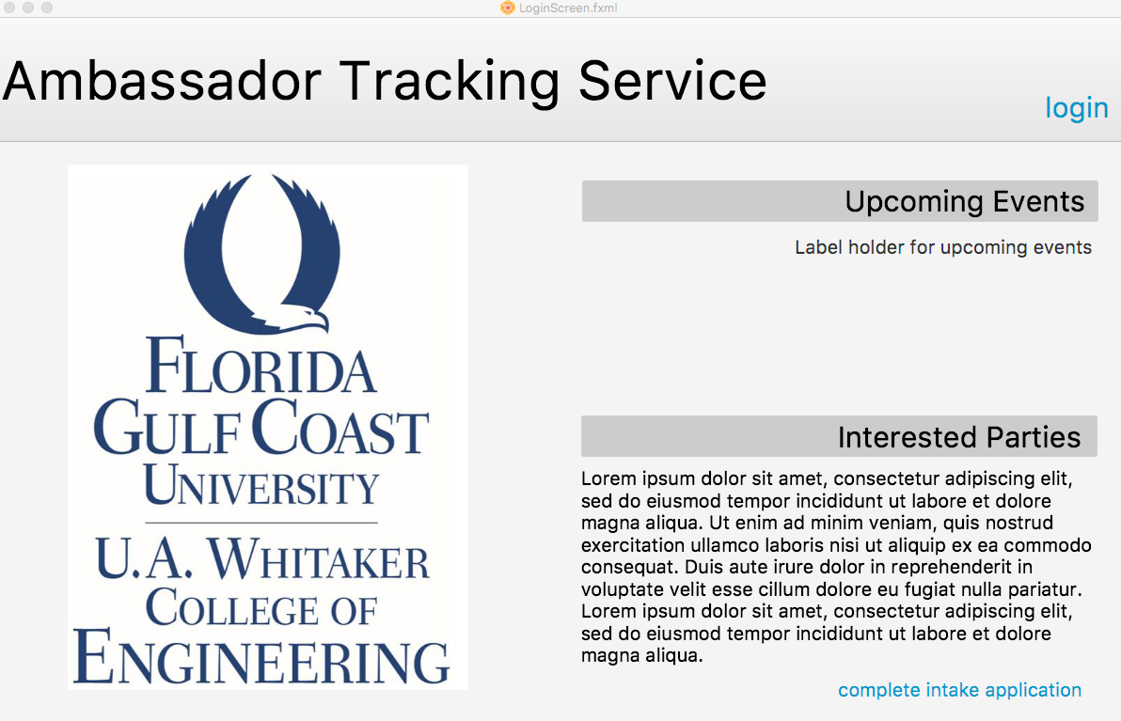

**Coordinator Homepage (below)** displays current ambassador tracking statistics including a pie chart representing the percentage on ambassadors occupies by each major, a line graph depicting attendance for each event, and agenda event for the day. Under the pie chart, the total hours collected by ambassadors and number of active ambassadors is displayed. The notifications section allows the coordinator to view incoming applications, service hour requests from current ambassadors, and to dos for events.

